HOFFMAN SPELLING- NOV 1ST- 5THtth

* three-letter clusters

- spring

- knee

- throw

- patch

- strong

- wrap

- three

- watch

- street

- know

- spread

- write

- strength

- kitchen
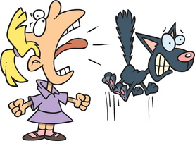
- wrinkle

- scream

- monster

- knight

- complain
- laughter

