HOFFMAN SPELLING JAN 14TH -25THth * vowel + r

1. hair

2. care

3. chair

4. pair

5. bear
6. where
7. scare

8. air

9. pear

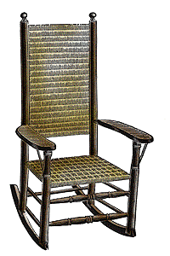
10. bare

11. fair

12. share

13. compare

14. stairs

Story/Challenge Words
15. ashore

16 burrows

17. launching
18. stranded

19. uninhabited

20. venture

