HOFFMAN SPELLING- NOV 12TH – 20TH * Long I sound- spelled I, igh, ie


- wild

- bright

- die

- sight

- child


- pie

- fight

- lie

- tight

- tie

- might

- mind

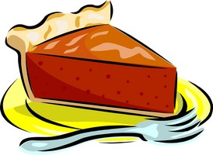
- design

- delight

Challenge/story
- May
- June

- respect

- elders
- ancestors

20. honor

